Review of Literature
The purpose of this research experiment was to find which skin bacteria attracts Anopheles gambiae mosquitoes, and if higher concentrations of certain bacteria are more or less attractive to these mosquitoes. Three different bacteria, Staphylococcus epidermidis, Bacillus subtilis, and Micrococcus luteus, were grown in Petri dishes with nutrient agar. Seven different bacteria samples were cultured: samples of each singular bacterium, samples of each combination of two bacteria, and a sample of a combination of all three bacteria. Single bacteria applications samples were used to show mosquitoes’ attraction to that individual bacterium. Combination bacteria applications plates were used to find if a mixture of bacteria was enough to mask the smell of individual bacterium and ward off mosquitoes.
Next, the bacteria samples were exposed to the mosquitoes. Petri dishes containing the various bacteria samples were taped onto the wall of a cage containing mosquitoes. In each trial two of the current bacteria samples being tested and two control dishes were placed in the cage. A heating pad was attached to the outside of the mosquito cage to heat up the bacteria plates during the trial. Each trial lasted ten minutes, and the number of mosquitoes observed to touch the bacteria sample was used to determine that sample’s attractiveness.
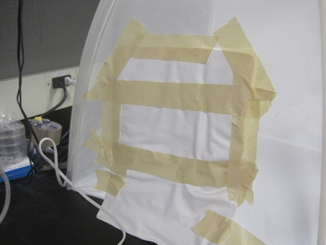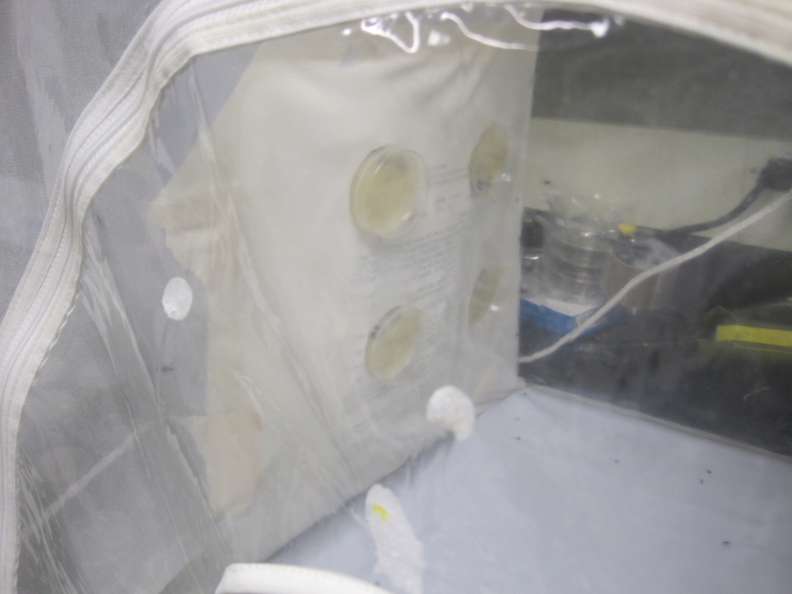
Figure 4. Mosquito Cage Set-Up

Figure 4 above shows how the heating pad was attached to the outside of the mosquito cage, and how the four Petri dishes were attached the inside of the mosquito cage. The Petri dishes were placed on the wall so they would be closer to the flying mosquitoes that tended to gravitate toward the sides and top of the cage. Attaching the heating pad to the outside of the cage allowed the plates to be directly heated while the netting of the cage was still exposed for easy mosquito landings.
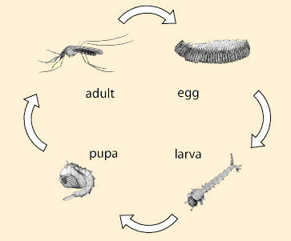
Figure 2. Life Cycle of Mosquitoes
("Biological Notes on Mosquitoes")

Mosquitoes go through four stages of life, from egg, to larva, to pupa, and finally to adult. A diagram of this life cycle is shown above in Figure 2. Only adults are able to fly around, and from these adults, only females need a blood meal. Mosquitoes actually get their food from plant nectar, but females need the extra nutrients from blood in order to lay eggs ("Biological Notes on Mosquitoes"). Female mosquitoes drink enough to fill up there abdomen, which ranges from 0.001 to 0.01 milliliters in size. This doesn’t seem like much, but each female feeds approximately every two days, and thousands of mosquitoes are always looking for hosts. Mosquitoes bite using their proboscis, which penetrates their host’s skin and sucks blood while injecting their own saliva into the host. Their saliva can contain deadly viruses, such as West Nile Virus and Malaria, which can be spread to their hosts when biting (Mosquito FAQ’s).
Mosquitoes smell with their antenna, and nearly half of their brain is dedicated to analyzing smells with olfactory receptors (Jarell). Each receptor is used to pick up a certain scent, and when activated it sends off electrical signals in the olfactory bulb, which is able to detect what the mosquito smells. In the human brain, after detection the smell is associated with memory and feelings, but in a mosquito the brain signal is used to determine the quality of their food or prey (How Smell Works). This attraction, or lack-of attraction, to a blood source tells the mosquito when to hone in and bite (Su).
Certain factors in particular lead to female mosquitoes being attracted to humans. In the field, it is commonly known that colors such as bright red and blue, carbon dioxide output, lactic acid output, and drinking beer all attract mosquitoes, but attraction extends deeper than these factors to the chemicals on a person’s skin (Nierenberg). A professional in the field, Dr. Logan, believes the key to repelling mosquitoes is recreating the bacterial composition or chemicals that naturally repels mosquitoes, rather than trying to mask the smells that attract them. Current repellents only aim to distract mosquitoes from attractive scents, rather than targeting the bacterial root of the problem (Wang). If it was concluded that combinations of bacteria can in fact help to repel mosquitoes, and a way was found to increase the number of bacterium on a person’s skin, then mosquitoes could be effectively repelled in the way Dr. Logan described.
For the last 50 years mosquitoes have been repelled with sprays that include the chemical compound DEET. Until recently it wasn’t understood why this work, until an experiment was conducted at Howard Hughes Medical Institute by Leslie Vosshall. This experiment looked at four olfactory receptors in fruit flies, which act very similar to mosquitoes. When exposed to DEET the olfactory receptors being tested didn’t respond at all, but when exposed to other smells at the same time, the receptors behaved differently. Vosshall believes the compound works as a repellant by momentarily confusing mosquitoes olfactory receptors, making them not attracted to regular attractants (How Does DEET Work?).
But DEET repellants may no longer be an effective approach to warding off the pesky insect. An experiment was conducted to test just how well repellents work. Mosquitoes were exposed to the main chemical used in bug sprays, DEET. After three hours of exposure, the effects had worn off completely, making mosquitoes immune. Certain species were even discovered to have a genetic insensitivity to the chemical (Stanczyk). Though DEET may have been effective when it was discovered 50 years ago, mosquitoes have evolved to fight against its effects. In order to properly repel mosquitoes it is necessary to look further, to the root of the problem, which lies in the chemicals on human’s skin.
A study was conducted at Rothamsted University to investigate which chemicals on the skin would attract mosquitoes most. Human volunteers were exposed to mosquitoes, and the ones that were attractive to the mosquitoes were separated from the ones that were not. The two groups were then put in body-size foil bags for two hours, and the chemicals collected in the bags were examined afterwards. People who were more likely to be bit had high amounts of different chemicals on their skin than people who weren’t. Two chemicals were found to be significant mosquito repellents, including 6-methyl-5-hepten-2 and geranylacetone. When these chemicals were applied to the mosquito attracting people, the mosquitoes would no longer bite them (Wang).
Chemicals on a person’s skin do not give off their own odor, so how is it that they can attract mosquitoes? The answer lies in the bacteria that live on people’s skin. When people sweat, the bacteria colonies living on the skin eat the sweat, which includes chemicals that are also present on the skin. The waste the bacteria leave behind is what gives off body odor. Different bacteria types give off different odors and mosquitoes can detect all of these individually (Smallegange). Due to this source of odor, the bacteria composition of a person’s skin is one of the main factors that determine their attractiveness to mosquitoes (The Role of Skin Microbiota…). This research aimed to investigate which bacteria would attract mosquitoes most, and further look into what properties affected this attraction.
Recently, a study was conducted by Julia Segre from the National Human Genome Research Institute to understand more about bacteria that occurs on human skin, and find possible ways of preventing bacterial skin diseases. Skin samples were taken from human volunteers, then these samples were analyzed by sequencing the 16S ribosomal RNA genes. This particular type of DNA is specific to bacteria, and was able to reveal the bacterial compositions of the skin samples. The study found that there are more than 112,000 bacteria gene sequences living on human skin, and that the more diversity of bacteria, the healthier the skin sample. Each person’s bacterial make-up is slightly different, causing difference in mosquito attraction from person to person ("Study finds unexpected bacterial...”). Mosquitoes may also prefer certain bacterial odors to others because of the amount of carbon dioxide emitted by the bacteria colony, which turns oxygen into carbon dioxide through aerobic respiration (Carbon Dioxide).
Another experiment conducted at the University of Idaho further suggests that a balance of bacteria is healthy, but both studies show that too much of one bacteria, especially Staphylococcus, can lead to infections (University of Idaho). When investigating which bacteria repel mosquitoes, and trying to figure out a solution from this information, it is important to keep in mind bacteria can be dangerous in high amounts.
The bacteria used in the experiment discussed in this paper were selected because of their difference in smell, and previous testing in the field. In an experiment conducted at Wageningen University, in the Netherlands, mosquitoes’ attraction to five different bacteria naturally found on the skin was tested. Shown below, in Figure 3, are the mosquitoes’ responses to each of the bacterium.
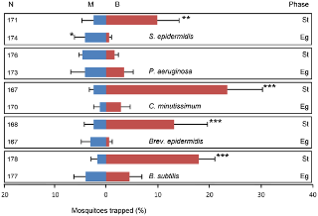
Figure 3. Mosquitoes’ Attraction to Certain Bacteria
(“Differential Attraction of Malaria Mosquitoes…”)

The graph shows that four of the five bacteria attracted mosquiotes, two of these being Staphylococcus epidermidis and Bacillus subtilis. It also shows that bacteria were attractive in their stationary growth phase, rather than their exponential growth phase (“Differential Attraction of Malaria Mosquitoes…”). During bacteria’s exponential growth phase, or log phase, bacteria colonies rapidly expand. Following this phase is the stationary phase, where the level of bacteria remains near constant (“Bacterial Growth Curve”). In this experiment, bacteria samples were allowed to culture in an incubator for two days, where they reached their exponential growth phase and began to level off near the end. When they were removed from the incubator the bacteria samples were in their stationary growth phase.
Staphylococcus epidermidis and Bacillus subtilis were taken directly from the research experiment conducted at Wageningen University. Micrococcus luteus, though not tested in Wageningen University’s experiment, is close to bacteria that were tested and is known to grow naturally on the skin. The use of these bacteria may have led to better data because they were previously known to be mosquito attractants. The experiment at conducted at Wageningen University proved that lab grown bacteria, in agar, can simulate the smell of bacteria on human skin enough to attract mosquitoes, further justifying this research experiments data.

In another similar experiment conducted at Wageningen University glass beads were rubbed on human volunteer’s feet, and the bacteria collected was allowed to grow. The glass beads were then set in a trapping device connected to a cage of mosquitoes, and the amount of mosquitoes stuck in the trapper after fifteen minute periods was used to determine the sample’s attractiveness. The results of Wageningen University’s experiment found that especially attractive human bacteria samples were high in Staphylococcus epidermidis, while the few samples that actually repelled the mosquitoes were high in Pseudomonas aeruginosa. The experiment results also suggested that more of a blend of skin bacteria can help repel mosquitoes (“Composition of Human Skin Microbiota…”). This is where the hypothesis, that bacteria combinations will be less attractive than single bacterium samples, was derived.

In both experiments conducted at Wageningen University trapping devices were used to determine bacteria sample’s attractiveness to mosquitoes. The way bacteria samples were exposed to mosquitoes in this experiment mirrors the basic set-up of these trapping devices, shown below in Figure 6.

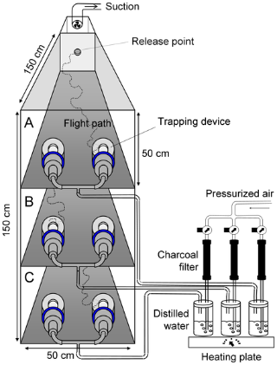

Figure 6. Trapping Device

(“Differential Attraction of Malaria Mosquitoes…”)

Mosquitoes were released at the top of these devices, and allowed to fly through tiers of trapping devices. The trapping devices had bacteria samples and controls, which gave the mosquitoes a choice, helping to determine the real attraction of the bacteria sample by ruling out random mosquito behavior. Distilled water was pumped into the trapping devices to warm up the samples, while the pressurized air and suction kept the air in the trapping device fresh to eliminate odors besides those of the bacteria samples (The Role of Skin Microbiota…). In this experiment mosquitoes were also given a choice between different bacteria samples, and the samples were heated. Though the set-up is much cruder, it takes the most important factors from the set-up used in the Wageningen University experiments.
Aspects were taken from both Wageningen University experiments to help design this research experiment. Due to this, the data collected in this experiment will expand on previously collected data and give further insight to mosquitoes’ relationship to skin bacteria.
Works Cited
"Biological Notes on Mosquitoes." Mosquitoes.org. Alameda County Mosquito
Abatement District, n.d. Web. 22 Sept. 2013.
<http://www.mosquitoes.org/LifeCycle.html>.
Nierenberg, Cari. "Why Some People Are Mosquito Magnets." NBC News Health.
NBC News, 29 May 2011. Web. 22 Sept. 2013. <http://www.nbcnews.com/health/why-some-people-are-mosquito-magnets-1C6437380>.
Smallegange, R., and Niels O. Verhulst. "Sweaty Skin: An Invitation to Bite?" Trends
in Parasitology (2011): 143-48. Wageningen UR. Wageningen University. Web. 20 Sept. 2013. <http://www.wageningenur.nl/en/Publication-details.htm?publicationId=publication-way-343034353433>.
Stanczyk, Nina M., John Brookfield, Linda M. Field, and James G. Logan. "Aedes
Aegypti Mosquitoes Exhibit Decreased Repellency by DEET following Previous Exposure." (n.d.): n. pag. PLoS ONE. Creative Commons Attribution License, 20 Feb. 2013. Web. 22 Sept. 2013. <http://www.plosone.org/article
/info%3Adoi%2F10.1371%2Fjournal.pone.0054438>.
"Study finds unexpected bacterial diversity on human skin." Dermatology Nursing
July-Aug. 2010: 41+. Academic OneFile. Web. 22 Sept. 2013.
University of Idaho. Bacterial Pathogens and Normal Flora of Human. 5 Aug. 2011.
Laboratory Experiment. University of Idaho Department of Biological Sciences.

Verhulst, Niels O., Y. Qiu, and H. Beijleveld. "Composition of Human Skin

Microbiota Affects Attractiveness to Malaria Mosquitoes." PLOS ONE (2011): 7. Wageningen UR. Wageningen University. Web. 20 Sept. 2013. <http://www.wageningenur.nl/en/Publication-details.htm?publicationId=publication-way-343138353339>.
Verhulst, Niels O., Rob Andriessen, and Gabriella Bukovinszkine-Kiss. "Differential
Attraction of Malaria Mosquitoes to Volatile Blends Produced by Human Skin Bacteria." (2010): n. pag. PLOS ONE. Web. 20 Sept. 2013. <http://www.plosone.org/article/info:doi/10.1371/journal.pone.0015829>.
Verhulst, Niels O. The Role of Skin Microbiota in the Attractiveness of Humans to the
Malaria Mosquito Anopheles Gambiae Giles. Thesis. Wigeningen University, 2010. N.p.: n.p., n.d. Print.
Wang, Shirley. "Finding Smells That Repel." The Wall Street Journal. Dow Jones &
Company, 1 Sept. 2009. Web. 22 Sept. 2013.
<http://online.wsj.com/article/SB10001424052970204660604574378933761528214.html>.

