Review of Literature
The need for medical flights and rescue helicopters is steadily growing today in the world. There are accidents all throughout the world where people are stranded in the arctic tundra’s or near the top of Mt. Everest. In these circumstances, a rescue flight is necessary. There are also situations where a group of people or an individual needs to be airlifted to the nearest hospital; like going in an ambulance but instead of on the ground they are transported in the sky. Since these helicopters are so similar to ambulances, it is important that they have the same tools and equipment in them. It is as equally important that if a person needs to be operated on during transportation the doctors and surgeons do not have to worry about turbulence and other parts of aerodynamics.
Aerodynamics is the study of air flow over objects (“Aerodynamics”). There are many forces of general aerodynamics that will affect a helicopter when it is in flight. These forces come will act in different directions and in different magnitudes, depending on the specific characteristics of the flying object. The most significant of these forces are lift, thrust, drag, and weight. Lift is the upward force created by the effect of airflow as it passes around an airborne object. A helicopter’s mass is opposed by life to allow it to become airborne. Thrust is the force that opposes lift and propels the helicopter through the air. Drag is the force that opposes lift and thrust and is the retarding force created by development of lift and the movement of an object through the air. Figure 1 on the next page shows how these forces act upon the helicopter.
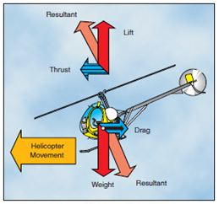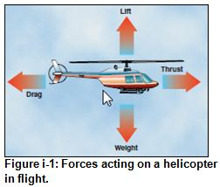
Figure 1. Forces Acting on a Helicopter
The type of airflow also affects how a helicopter flies. There are two types of airflow: laminar and turbulent. Laminar flow is often described as being smooth where the air flows in the same pattern, same direction and at the same speed. Turbulent flow is the opposite of laminar flow. In a turbulent airflow, the air flows in any direction, has no pattern and consists of many different speeds (Nagel). Figure 2 below shows the differences between turbulent and laminar flow.
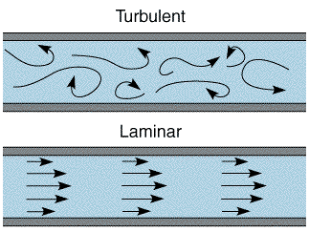
Figure 2. Turbulent and Laminar Flow
A turbulent airflow causes turbulence, which is the formation of eddies in a fluid – a liquid or a gas (Lerner). Turbulence is measured by the Reynolds number, which is found by taking the inertial force and dividing it by the frictional force (Lerner). Turbulence is often experienced in airplanes. When the pilot calls to the passengers to put their seatbelts on because of turbulence, it is because the turbulent airflow is causing the plane to experience airflow with different speeds and multiple directions. This can sometimes be dangerous to passengers.
While there are no experiments exactly like this one, there are a few experiments that are slightly similar. In one similar experiment, a new method for evaluating the analytical hierarchy process (AHP) based on linguistic variable weight was researched. The importance of the relative weight is first measured, and once that is calculated, the centralization or dilation power of linguistic hedge can be determined. After, the results of decision-making can be calculated. This constructs a practical example for evaluation attack helicopters that could illustrate the researchers’ proposal method (Cheng). This experiment is not exactly similar to our experiment; however, it does use mass to determine a factor, which is what our experiment will be on.
Another experiment done explored the effect of different Cellulose Helicopter Company on the flight time without altering the stability or flying capacity of the helicopters. Factors of body and wing width and length, weight, and others were used. While this experiment is different in that the dependent factor is time rather than acceleration, the design of the two experiments is very similar. Additionally, both experiments could be used as further research for the other.

Cheng, Ching-Hsue, Kuo-Lung Yang, and Chia-Lung Hwang. "Evaluating Attack
Helicopters by AHP Based on Linguistic Variable Weight." Evaluating Attack Helicopters by AHP Based on Linguistic Variable Weight. Elsevier B.V., 1999. Web. 04 Oct. 2013.

Zholud, Dmitrii. "The Paper Helicopter Experiment." The Paper Helicopter Experiment. Http://www.paperhelicopterexperiment.com/, 2013. Web. 11 Oct. 2013

