Appendix B: Formatting Formulas

**How to reference and format a formula/equation in your paper:**

**Example:**

Plank gave the name quantum to the smallest energy that can be emitted or absorbed. He proposed that energy,, of a signal quantum number equals a constant, , times its frequency, .



Others built on his contributions by…….(Continue paragraph here)

**How to reference and format sample calculations**

**Note:** The original formula is centered, but not the actual sample calculation **and** that the units are identified throughout the work. **Sample Calculations and formulas are formatted using Equation Editor.**

**Example:**

To analyze our data we needed to use the following equation where energy, , of a single quantum number equals a constant, , times its frequency, .



Shown in figure 1 below is a sample calculation using the equation for the energy of a photon.



Figure 1. Energy Equation

Sample calculation of the energy of a photon.

**How to Use Equation Editor**

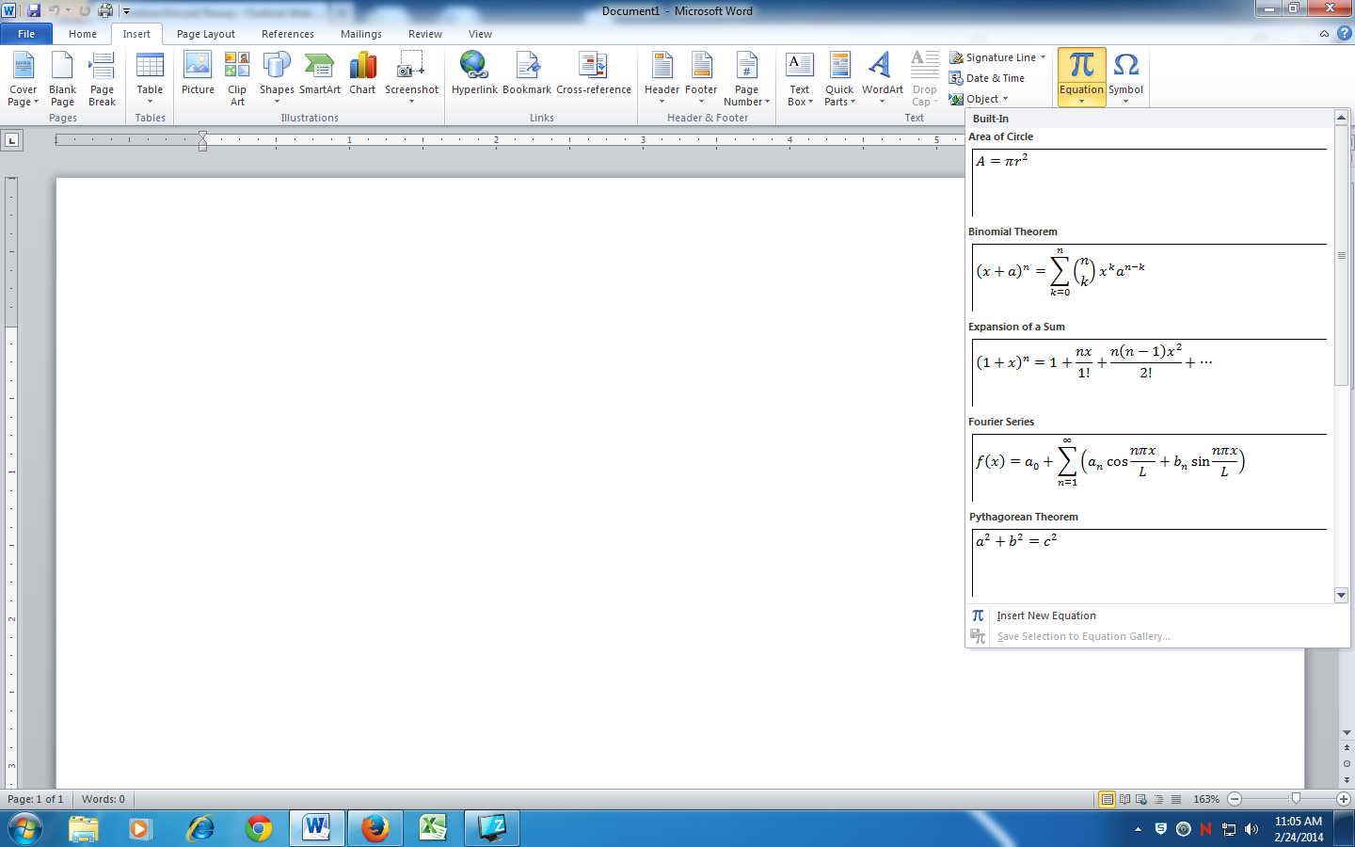

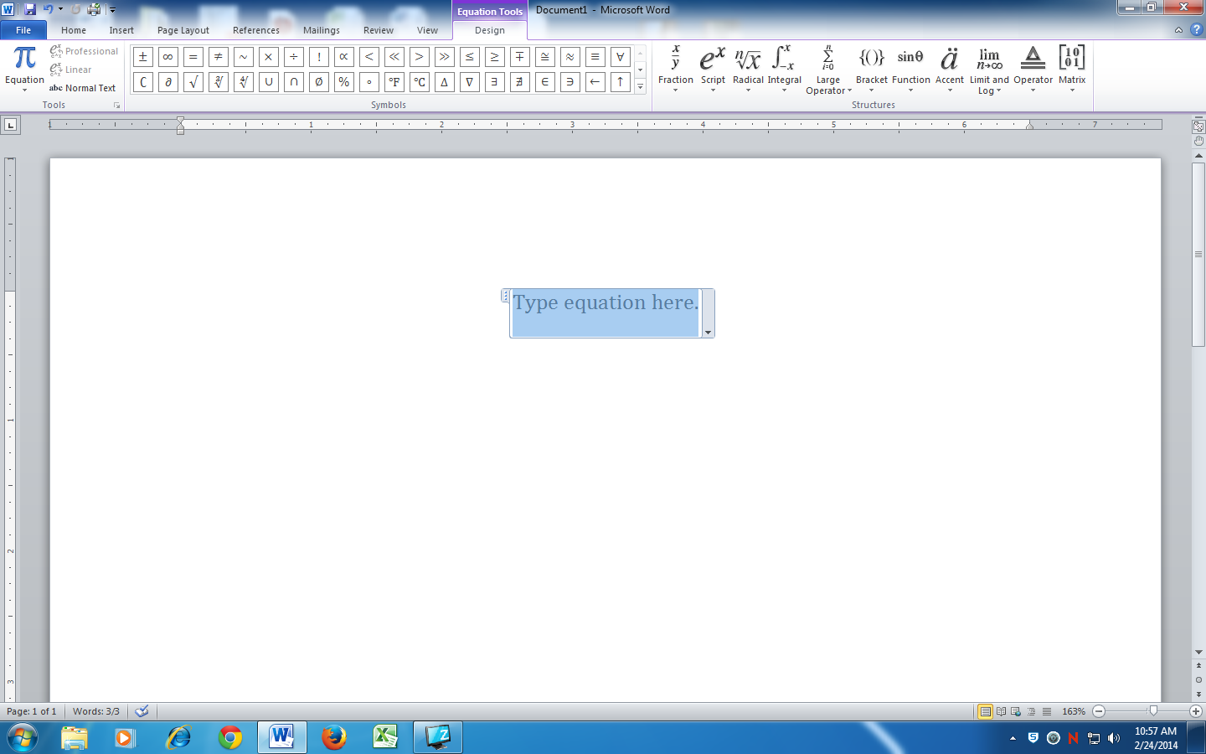

**How to calculate percent error**

Experimental value is what you calculated in the lab.

True value is the published value for that property.

You need to calculate % error for each property and this should be reported in a table.

