Notes on How to Improve Your Density Lab/Research

- Formulas should not be formatted as a figure
Specific heat is the amount of heat required to raise the temperature of one gram of a substance by one degree Celsius, or one Kelvin (Chang 239). Using the following equation, the specific heat of a substance can be found. Specific heat, s, equals the change in heat, q, divided by the product of the mass of the substance, m, and the change in temperature, ∆T.
It is expressed with the unit: Joules per gram Kelvin or Celsius (J/g * K or J/g * ○C ). Either temperature scale can be used because they increase at the same rate, but start at different values. For an accurate measurement of specific heat, experiments must be run in isolated systems, a system where matter and heat are not lost, to prevent losing mass or heat to the surroundings (Chang 225).
- Sample Calculations SHOULD be formatted like a figure and MUST have units
Figure 1. Energy Equation
Sample calculation of the energy of a photon.
- You must have units after a number! Be it in a figure, or an anchor or in a sentence!

- Box plots need labels and interpretation.

`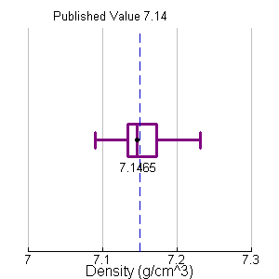
Figure 4. Density Box Plot
Figure 4 above shows the box plot of the density values found in the experiment.
The values are evenly distributed, with a slight slant towards the right. Due to the standard deviation (0.033 g/cm³) being so close to zero, the data was centered around the mean (7.153 g/cm³) with little variation. The median of the data (7.1465 g/cm³) and the true value (7.14 g/cm³) are both labeled in the figure. The published value is represented by a dashed vertical line.
- Diagrams need labels

- Percent error tables need to tell the reader what metal you compared your unknown too. We don’t need to see every trial just the averages.

Table 1
Percent Error Table
 | Nickel | Cobalt
Experimental Average  (g/cm³) | 8.832 | 8.832
True Average  (g/cm³) | 8.912 | 8.800
Percent Error  (%) | -0.899 | 0.364

Table 1 above shows…..

- Do not start a section of the paper with a figure, table, graph, sample calculation. You need a paragraph to set the stage for what the reader will find.

- Do not start a sentence with “Because” or a number “30”

- In the conclusion it should be clear to the reader in the first paragraph what your conclusion is. For this lab the reader should know the identity of your metal after reading paragraph one!

