Name:___________________________________

Virtual Lab: Activity Series and Redox Reactions
Background:
The usefulness of metals in structural and other applications depends on their physical and chemical properties. Although iron is the most common metal used in manufacturing, it must be protected against corrosion because rusts easily. Copper is used in electrical wiring because it conducts electricity extremely well and resists corrosion better than many metals. Gold is a highly valuable jewelry metal because it is essentially unreactive. How can we determine the relative reactivity of different metals?
To determine the activity of metals you can compare the reactions of metals with different
metal ions. Consider equation 1 and 2 below:
2Al(s) + 3CuCl2(aq) --> 2AlCl3(aq) + 3Cu(s) (Equation 1)

_________________________________________ LEO ________ GER________
Cu(s) + AlCl3(aq) --> No Reaction (Equation 2)
The reaction of aluminum with copper (II) chloride (Equation 1) is classified as a single replacement reaction – aluminum reacts with and “replaces” copper ions in copper (II) chloride. Single replacement reactions will occur spontaneously in one direction only (compare Equations 1 and 2). A more active metal always replaces the ion of a less active metal. In general, the activity of a metal may be defined as follows:
An active metal will react with a compound of a less active metal, which is converted to its “free element” form. The more active metal forms a new compound containing metal cations. Based on Equation 1, aluminum is more active than copper and therefore replaces the copper by undergoing a redox reaction.
Procedure:
1. Click on the link below or copy and paste it into your browser.
http://intro.chem.okstate.edu/1515F01/Laboratory/ActivityofMetals/home.html
2. Click START. (For this simulation Do Not click the back button on the browser or you will quit the simulation and have to start over!!!!) CLICK OK.
3. Click Activity 1.
4. Using your mouse click on the first metal (Mg) then click on the box that says [click here to place the metals in the solutions]. Refer to the items circled in red below:
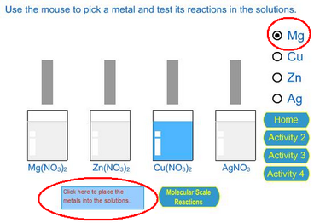
The copyright for these simulations are with the chemical education research group at Iowa State University
5. After a few seconds the reactions will be complete and it will say now you can remove the metals from the solutions and record your observations. Click on the box that says: click here to remove the metals from the solutions. Refer to the items circled in red below:
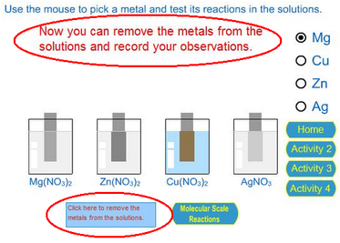
The copyright for these simulations are with the chemical education research group at Iowa State University
6. Once the metals are removed from the solutions record your observations (any changes in color, size, texture) in data table 1. If no reaction occurs write no reaction in the box.
7. Now repeat steps 4-6 for the next three metals (Cu, Zn and Ag).
8. In data table 2 write the balanced equations for the reactions that occurred. (hint: these are single replacement reactions)

Data/Observations:

Table 1.
Aqueous Solution | Solid Metal Strip
 | Mg | Cu | Zn | Ag

Mg(NO₃)₂

Zn(NO₃)₂

Cu(NO₃)₂

Ag(NO₃)

Table 2.
Reaction | Balanced Reaction  with Oxidation Numbers
1
2
3
4
5
6
Questions:
1. Which of the metals reacted with the most solutions?

2. Which of the metals reacted with the fewest solutions?

3. List the 4 Metals in order from the most reactive to the least reactive.

Most _________ > _________ > _________ > __________ Least
4. Refer to the activity series below. This is the activity series which lists the most reactive metals on top and the least reactive on the bottom. Compare your answer to question #3 with the activity series. Are your results in the same order? Why? Use your data in tables 1 and 2 to support your claim.

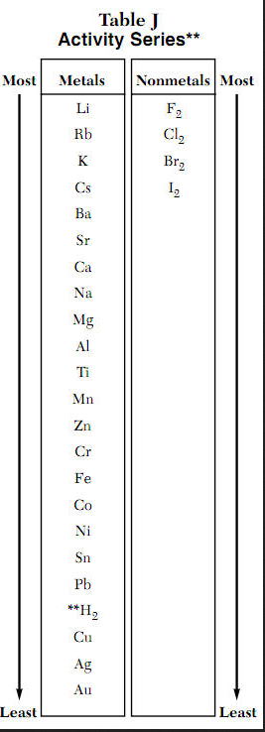
5. If we added Pb to the list, which of the solutions would you expect it to react with?

