Instructions: Pick any three of the options to demonstrate your understanding of the mole concept. The three MUST be in a row either horizontally, diagonally or vertically. BONUS Square: CHOOSE ONE! You may not repeat the Bonus you did last time

Let’s Get Creative  Find a way to illustrate TWO of the gas laws. You can create your own song, write & illustrate a story, create a dance routine, or some other creative/artistic and out-of-the-box way of showing how the KMT relates to TWO of the FIVE gas laws. Depending on your media/choice, you might have to do a brief written explanation. | Flash card frenzy.  For the vocabulary for the unit, create 10 Frayer model cards. Template is located with instructions. You must do acid, base, molarity, and concentration. The word should be identified based on the sections of your Frayer model. | Healed & Sealed  Watch the video illustrating and explaining the famous vanishing can magic trick. Using your understanding of the material in the unit, explain the CHEMISTRY involved in the magic trick.
Apply Yourself  Research a common real-life application of one of the gas laws. Write a one page report explaining how the application applies to the law | Which (law) is Which?  Watch/read the links and identify the gas law being observed. You may record your information in the table provided (make sure you are detailed!!). Identify the Gas Law and how the demonstration works. | How Much Pop is in your Popcorn  This choice involves examining data from an actual lab. Once you have read the lab and looked at the data, calculate how much pressure is required to pop the popcorn.
The One that shut down schools  COVID-19 or the Corona Virus often results in people with symptoms ending up in hospital and requiring the use of supplemental oxygen or a ventilator to supply oxygen. Record a video about how gas laws and ventilators are related. | DeflateGate Case Study  In January 2015, the New England Patriots were accused of altering the inflation levels of the footballs used in the AFC Championship Game. Read the details and answer the questions about the who/why of this sporting scandal. | One Pager  Read the four articles about the gas laws and applications. Choose one article and create a one-pager for the article. Follow ALL directions. Be sure you relate the article to the Unit Topic!

NOTE: All work on your THREE choices should be visually appealing. The quality of work should be evidence of time well used and material well understood! Please make sure your written submissions are edited for grammar, spelling, and punctuation. Each square is worth 10 points. DUE: May 17th. Rubric for grading can be found below. The total assignment is 50 points. You will have a 3-2-1 discussion for the last 10 points. There is a rubric for grading at the very end of this document.

BONUS: Chemistry of Workouts  Complete a 10-15 minute workout of your choice. Afterward, take a sweaty selfie and write a paragraph explaining the benefits of working out. In your explanation, please relate working out/endorphins to ONE aspect of the chemistry we have learned this semester. | BONUS:Chemistry of Walks/Hikes  Take a 10-15 minute walk or hike in the local area near your home. Take a picture on TWO items on your walk/hike. Place the pictures in a document and explain the chemistry of these two pictures. | BONUS:Chemistry of Kindness  Do a good deed or a kind act for someone in your house or neighborhood. Take a picture & write a journal entry--10 sentences--about how the act of being kind made you feel and how you think it might have made the other person feel. Explain ONE connection of act of kindness to chemistry.

How much POP in your popcorn: https://docs.google.com/document/d/1FLhbI9qbkTUu4FYCeFP4tE0QT61dAbFhHxE-Znej7aM/edit?usp=sharing
Healed & Sealed: https://docs.google.com/document/d/1vtBE4V7ovwIvVAHDVCPSP87J3kOBbpyUqJ--gmzPR4Y/edit
Let’s Get Creative: https://docs.google.com/document/d/1E9gza7SNtz9gh3yPW_EGTvDsI1KEi6EpiSMbTTSf2nw/edit?usp=sharing
Deflategate Case Study: https://docs.google.com/document/d/1ydV0f3HYZVLDtaCXyEVx3MZG8DMWM7gWtNGkTc1xttQ/edit?usp=sharing
The One that Shut Down Schools: https://docs.google.com/document/d/1AwTLWnLMVjlInDQO4dfTP5wpngCIJiKa9Dr6_f-Rkj8/edit?usp=sharing
Which (law) is which: https://docs.google.com/document/d/1WZcPOz2u3LgjgVGhkYpXFnQxi8DOlPjyB1lcDcEoSPo/edit?usp=sharing
Apply Yourself: https://docs.google.com/document/d/1t9Tu2sBbIamuPcgXSfiyEWGT9h57CHqIcsW6IgtO0EI/edit?usp=sharing

One Pager Article Choices:
- Hot air Balloons--Gas & Go
- In the Fog About Smog
- Balloons to the Edge of Space
- Deflate Gate & the Scientists
One pager directions:
1. Write the title of the topic on the front of your page. Your name goes on the back.
2. Pull out two phrases from the video as it relates to the reaction you chose. Write these on the page. Be sure to include QUOTATION MARKS!
3. Include visual images that have a strong relationship to the topic. Minimum of TWO!
4. Write a summary about the article in general and its relationship to the topic in particular. It should be a MINIMUM of FIVE meaningful, thoughtful, well-constructed sentences.
5. Create a word cluster; these words can be pulled from the text or relate to the content.
6. Create ONE essential question and ANSWER it. This is not a question that can be answered with “yes” or “no.”
7. Create a border around the page that reflects the content, concepts, or message of the topic.
--You may draw images or use computer generated images.
--You can add other materials such as fabric, stickers, ribbon, etc.
--use colored pencils, black or colored ink.
8. All writing should be neat and done in ink or typed.
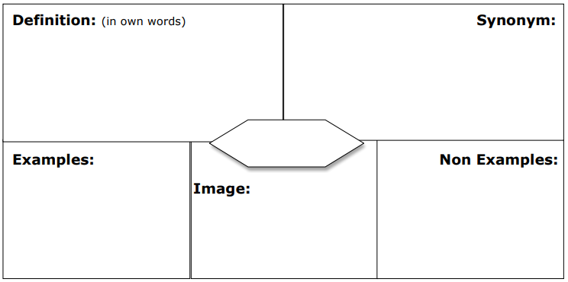
9. Your content should cover the entire page. VERY LITTLE BACKGROUND AREA SHOULD SHOW. APPEARANCE COUNTS!

Flash Card Frenzy Frayer Model template https://docs.google.com/drawings/d/1QSE6i9L-_EfC5mEQNVkG6lu-92U6wobZ1yPnT04KoSc/copy (editable template)
https://docs.google.com/document/d/1TPKCBYHtazT1X6xZV16xn5GSHrZOPZj8X6W5bBAzvZA/edit?usp=sharing
(instructions)

RUBRIC for Choice Squares.
 | 10 points | 7 points | 5 points | 3 points | 0 point
Choice one | Student has illustrated complete understating of the skill/concept described. | Student has illustrated understanding of the skill/concept described | Student illustrated incomplete understanding of skill/concept described | Student has many misconceptions about the skill/concept described. | Not enough information to make a judgment or student did not turn assignment
Choice two | Student has illustrated complete understating of the skill/concept described. | Student has illustrated understanding of the skill/concept described | Student illustrated incomplete understanding of skill/concept described | Student has many misconceptions about the skill/concept described. | Not enough information to make a judgment or student did not turn assignment
Choice three | Student has illustrated complete understating of the skill/concept described. | Student has illustrated understanding of the skill/concept described | Student illustrated incomplete understanding of skill/concept described | Student has many misconceptions about the skill/concept described. | Not enough information to make a judgment or student did not turn assignment
Aesthetics  Grammar & spelling  Attention to detail | Overall assignment is neat and student took time/effort to make it neat and colorful. No grammar or spelling errors | Overall assignment is neat and student took some time/ effort to make it neat and colorful. Less than 10 spelling or grammar errors | Overall assignment is legible and it had little color. Student did bare minimum. More than 10 spelling or grammar errors. | Assignment is sloppy and looks as though the student put no effort into the assignment. Excessive spelling or grammar errors | Not enough information to make a judgment or student did not turn assignment
Total |  |  |  |  | 40 points

