Doug Balmer, 2020
PhET Gas Laws Simulation
Directions: You will use this interactive model to get to know the properties of gases and the gas laws. The intro module is basically a sandbox where you get to play. We will be using the Laws module. | 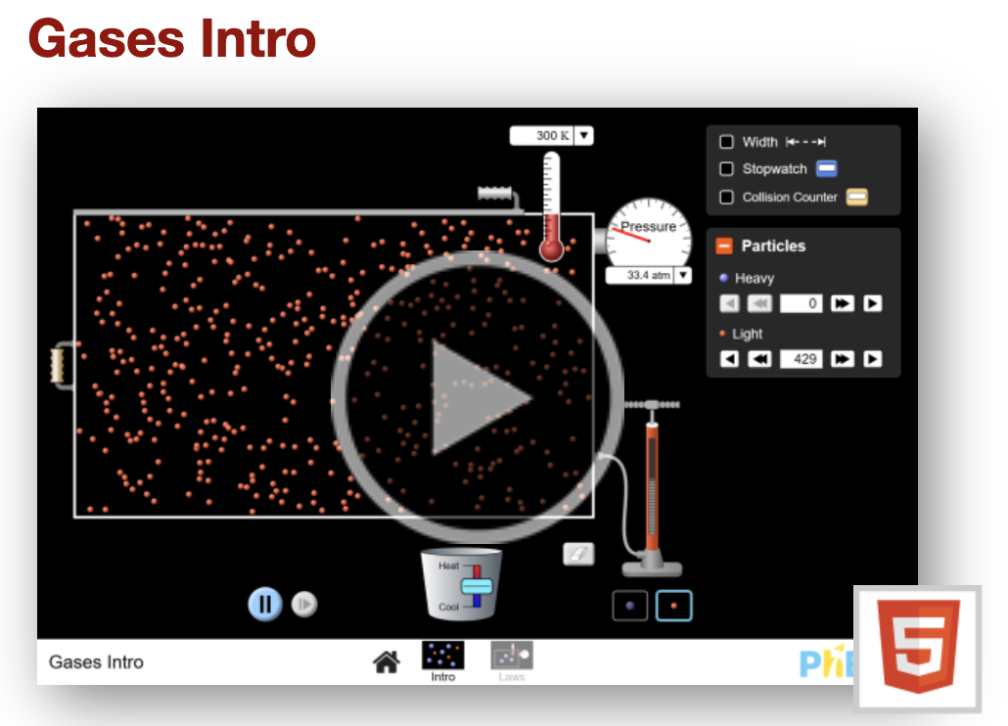 | 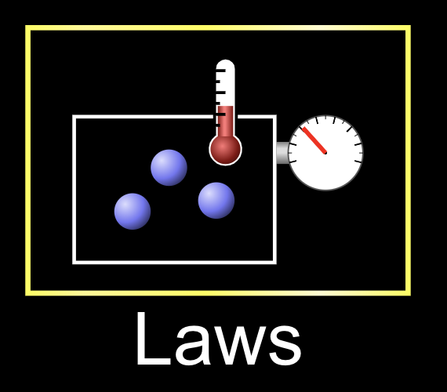

The scenario below will serve as our control to which we will compare every other scenario.
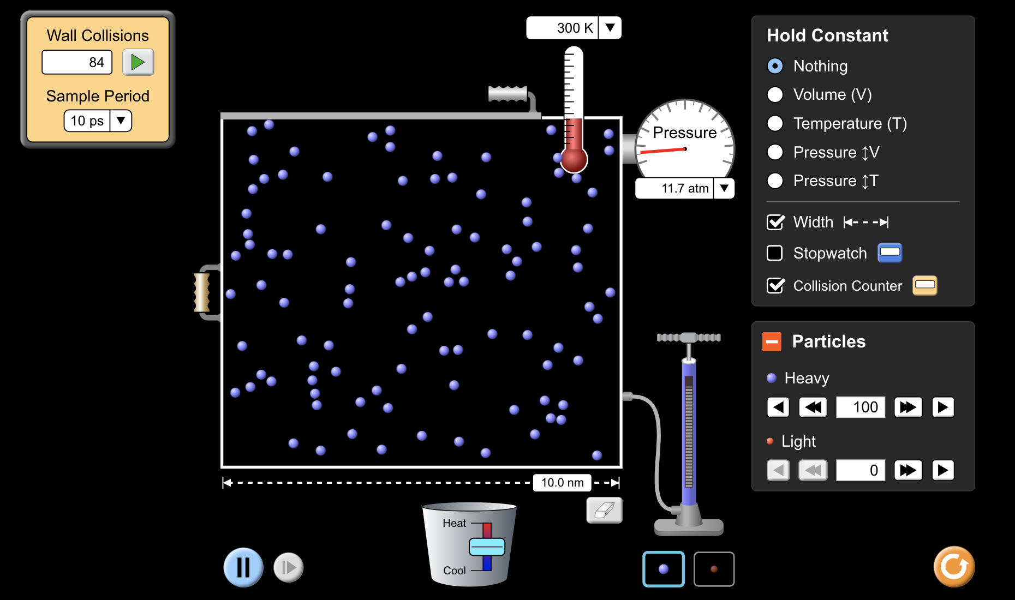 |  |  |  | Starting Volume  (width in nm)  5.0 nm | Starting Temperature (K)  300 K | Starting Pressure  (atm)  23.3 atm | Number of Gas Particles  100 Heavy  (100 H)

Gas Law | Math Equation | Relationship between Variables | Real-life scenario | Effect on Volume  (width in nm) | Effect on Temperature  (K) | Effect on Pressure  (atm) | Effect on the Number of Gas Particles
Boyle’s Law | P₁V₁ = P₂V₂ | V and P are inversely proportional | Scuba diving | Double the volume  (10.0 nm) | Constant  (300 K) |  | Constant  (100 H)
Charles’ Law | $\frac{V_{1}}{T_{K1}}=\frac{V_{2}}{T_{K2}}$ | V and T_{K} are directly proportional | Hot air balloons |  | Double the temperature (600 K) | Constant  (23.3 atm) | Constant  (100 H)
Amontons’s Law  (formerly Gay- Lussac’s Law) | $\frac{P_{1}}{T_{K1}}=\frac{P_{2}}{T_{K2}}$ | P and T_{K} are directly proportional | Exploding cans in a hot car  This can be simulated by continuing to increase the temperature. | Constant  (5.0 nm) | Double the temperature (600 K) |  | Constant  (100 H)

. . . Continued . . .
. . . Continued . . .

Gas Law | Math Equation | Relationship between Variables | Real-life scenario | Effect on Volume  (width in nm) | Effect on Temperature  (K) | Effect on Pressure  (atm) | Effect on the Number of Gas Particles
Avogadro’s Law | $\frac{n_{1}}{V_{1}}=\frac{n_{2}}{V_{2}}$ | n and V are directly proportional | Blowing up a balloon |  | Constant  (300 K) | Constant  (23.3 atm) | Double  (200 H)

Discussion Questions:

- Are the gas laws affected depending on whether you use heavy gas particles or light gas particles? If anything, what is affected by the size of the molecule? Hint: Turn on the collision counter (10 ps) and measure the control setup with heavy particles and then repeat using light particles.

- Do Charles’s Law and Amontons’s Law hold true if you double the Celsius Temperature?

- Starting with the control setup, start the timer and quickly open the top of the chamber using the handle .
  - How long does it take for half of the heavy particles to leave the chamber (100 → 50)?

  - How long does it take for half of the light particles to leave the chamber (100 → 50)?

  - This relationship is known as Graham’s Law of Effusion. Since both gases are at the same temperature, they must have the same average kinetic energy (½ mv²), where m is mass and v is velocity (like speed). Since both gases have the same average kinetic energy, you can state that ½ m_{L}v_{L}² = ½ m_{H}v_{H}². Multiplying both sides by 2 gives you m_{L}v_{L}² = m_{H}v_{H}². Rearranging the equation to get both masses on the same side of the equation will give you m_{L}/m_{H} = V_{H}²/V_{L}². In 3a and 3b, you probably noticed that the heavy gas particles took twice as long to diffuse as the light gas particles. This means that the light gas particles are moving twice as fast, V_{H}/V_{L} = ½. Therefore, V_{H}²/V_{L}² = ¼. How many times heavier is the heavy gas compared to the light gas?

  - If the light gas was Ne, what would be a reasonable identity for the heavy gas?

  - You might have noticed something special about temperature, as the gas particles were escaping. If not, go back and let the gas particles escape while watching the temperature. What happened to the temperature of the gas, as the gas particles were escaping? Here’s a nice little video example of this. There are some slides in your notes and problems in your unit packet that will practice this.

- Try changing two variables at the same time (i.e. doubling one and maybe doubling the other one). Did the 3rd variable do what you predicted?

Conclusion: Tell me something “NU”

New: What new modifications would you make to this activity? Be specific. You cannot say you wouldn’t make any changes. Don’t use the words change, different, etc. If you want to use something different, give me some specific examples.

Uncertain: What concepts from the activity are you still uncertain about? In other words, what questions do you still have after completing the activity? You cannot say that you are uncertain about nothing. If you have no uncertainties, then ask me a challenging question related to the activity you wish you knew the answer to.

