Density Lab

Introduction:
This project will be your first introduction to your sophomore research project. Your objective will be to identify an unknown pure metal sample using the intensive property of density. Please go to www.mmstcchemistry.weebly.com for supplementary materials.

Problem Statement:

Hypothesis:

Data Measured:

Density Experimental Design

Materials:

Unknown Metal Rod (2)
TESR Caliper 00530085 (0.01mm precision)
Scout Pro Electronic Scale (0.1g precision)
TI-84 Graphing Calculator

Procedures:
Be aware of safety precautions. Wear gloves, goggles, and appropriate attire.
1. Randomize all trials in order to ensure accurate results, allocating fifteen trials Rod A and fifteen trials for Rod B.
2. Find the mass of the metal rod in grams to the nearest tenth by placing it on the scale after the scale has been tarred. Record in appropriate column.
3. Using the caliper, find the length of the metal rod in mm rounded to the nearest hundredth. See Figure 2 for a photo of the caliper. Record in appropriate column.
4. Using the caliper, find the diameter of the metal rod. Divide this value by two in order to find the radius of the rod in mm rounded to the nearest hundredth. Record in appropriate column.
5. Use the following formula to solve for the volume of the metal rod. Volume is measured in cm³. Round to the nearest thousandth and record in the appropriate column. See Appendix B for a sample calculation.
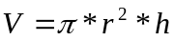
6. Divide the mass by the volume in order to find the density of the metal rod in g/mL, rounded to the nearest thousandth. Record in appropriate column.
7. Repeat steps 2-6 for thirty trials.
Diagram:
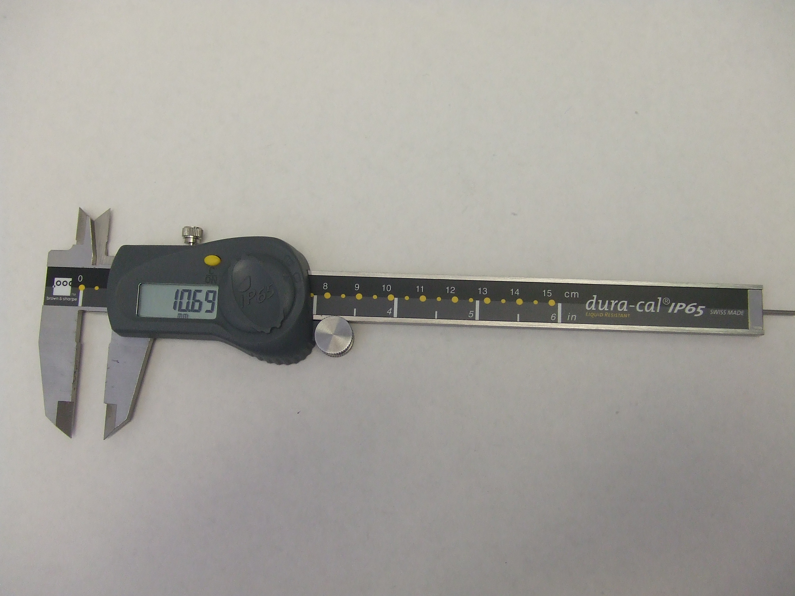
Output Screen

Measuring Prongs

Figure 2. Caliper
Figure 2 shows the caliper and its parts.
Data and Observations
Table 1
Density Values for Unknown Metal
Trial | Rod | Mass (g) | Radius (mm) | Length (mm) | Volume (cm³) | Density (g/cm³)
1
2
3
4
5
6
7
8
9
10
11
12
13
14
15
16
17
18
19
20
21
22
23
24
25
26
27
28
29
30
Average
.

Table 2
Density Observations for Unknown Metal
Trial | Observations
1
2
3
4
5
6
7
8
9
10
11
12
13
14
15
16
17
18
19
20
21
22
23
24
25
26
27
28
29
30

