Table 2
Chemical Treatment Trials
Trial | Type | pH | Trial | Type | pH
31 | Chemical | 5.04 | 46 | Chemical | 5.05
32 | Chemical | 5.06 | 47 | Chemical | 4.83
33 | Chemical | 4.88 | 48 | Chemical | 4.96
34 | Chemical | 4.92 | 49 | Chemical | 4.90
35 | Chemical | 5.30 | 50 | Chemical | 4.91
36 | Chemical | 6.04 | 51 | Chemical | 5.46
37 | Chemical | 5.12 | 52 | Chemical | 4.96
38 | Chemical | 4.81 | 53 | Chemical | 4.75
39 | Chemical | 4.99 | 54 | Chemical | 4.66
40 | Chemical | 4.74 | 55 | Chemical | 4.70
41 | Chemical | 5.09 | 56 | Chemical | 5.04
42 | Chemical | 4.70 | 57 | Chemical | 5.14
43 | Chemical | 5.43 | 58 | Chemical | 4.79
44 | Chemical | 4.63 | 59 | Chemical | 4.75
45 | Chemical | 4.96 | 60 | Chemical | 5.21
Average |  |  |  |  | 4.99
S. Deviation |  |  |  |  | 0.29

Table 2 shows the pH levels measured for the chemical treatment trials along with the average and standard deviation of the pH levels. The standard deviation is low, indicating little variability within the sample.

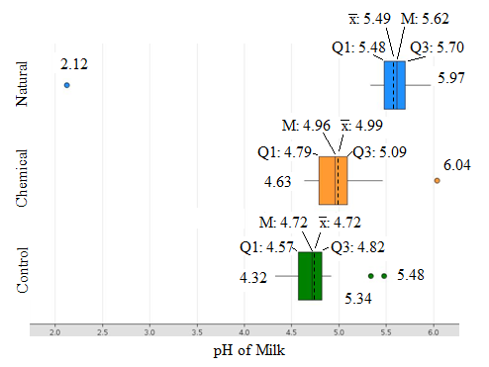
Figure. 7 Box Plots of Data Collected
Figure 7 shows the box plots created for the natural, chemical, and control trials. Points of interest have been labeled. The trials for the chemical and natural group appear to be skewed slightly to the right, and the trials for the control group appear to be left skewed. All treatment types have one or more indicated outliers. Because of this, the data was graphed again without outliers before any discussion of overlap began (see Figure 8).
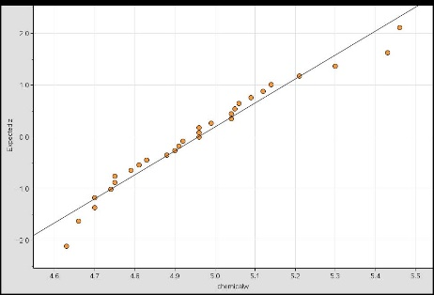
Figure 10. Normal Probability Plot for Chemical Group
Figure 10 shows the normal probability plot for the chemical group without outliers. The data is primarily in a linear pattern, indicating it is normally distributed.

